Digital temperature and humidity sensor DHT11 module

Module related introduction:
DHT11 digital temperature and humidity sensor is a contain has been calibrated digital signal output of temperature and humidity sensor complex. It is the application of the special digital acquisition module and temperature and humidity sensing technology, ensure that the product has a high reliability and excellent long-term stability. The product has quality excellence, fast response, strong anti-interference ability, price advantages. The single wire serial interface, allowing the system to integration become simple and quick. Ultra small volume, low power consumption, signal transmission distance up to 20 meters above the become to the class of applications for even the most demanding should occasion best choice for. Products for 4 needle single row pin package, Convenient connection.
Technical parameter:
Supply voltage: DC 3.3~5.5V
Output: single bus digital signal

Measurement range: humidity 20-90%RH, temperature 0~50

Measurement accuracy: humidity +-2, temperature +-5%RH

Resolution: humidity 1%RH, temperature 1

Long term stability: < + 1%RH/ years

matters needing attention:
- Avoid using in case of condensation
- Long-term storage temperature 10-40 degrees Celsius, humidity below 60%
- When using the power supply and ground connection method to correct, so as not to damage the sensor

Instructions：

DHT11 on the specific timing issues we can refer to its datasheet, the following look at how our company's module and Arduino board connection

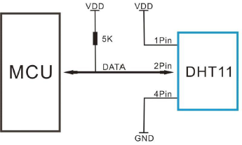

Above is its typical connection with the processor, there is a specific reference to the following

Module of the "+" end of the +5V output, "-" the end of the GND, "S" end of the digital port number 7 (of course, this can be defined by its own digital pin); the method is very simple, the following is left of the test phase......

Module function test:

hardware requirements

Arduino controller * 1

USB data line * 1

DHT 11 module * 1
In order to facilitate everyone to test, we have written a short test code, for reference only

int DHpin = 8;
byte dat[5];
byte read_data()
{
if(digitalRead(DHpin) == LOW)
{
while(digitalRead(DHpin) == LOW); //wait for 50us；
delayMicroseconds(30); //Determine the duration of the high level, to determine whether the data is' 0 'or' 1 '；
if(digitalRead(DHpin) == HIGH)
data |= (1<<(7-i)); //High in the former, low in the post;
while(digitalRead(DHpin) == HIGH); //Data '1', waiting for the next reception；
}
}
return data;
}
void start_test()
{
digitalWrite(DHpin,LOW); //Pull low bus, send start signal;
delay(30); //Delay should be greater than 18ms, so that DHT11 can detect the start signal；
digitalWrite(DHpin,HIGH);
delayMicroseconds(40); /Waitingfor the DHT11 response; pinMode(DHpin,INPUT);
while(digitalRead(DHpin) == HIGH);
delayMicroseconds(80); //DHT11 to issue a response, pull the bus 80us；
if(digitalRead(DHpin) == LOW);
delayMicroseconds(80); //DHT11 pulls high bus 80us to start sending data;
for(int i=0;i<4;i++) //Receiving temperature and humidity data, check bits are not considered;
dat[i] = read_data();
pinMode(DHpin,OUTPUT);
digitalWrite(DHpin,HIGH); //After sending a data release bus, waiting for the next time the host signal;
void setup()
{
Serial.begin(9600);
pinMode(DHpin,OUTPUT);
}
void loop()
{
start_test();
Serial.print("Current humdity = ");
Serial.print(dat[0], DEC); //Display the entire digital humidity;
Serial.print('.');
Serial.print(dat[1],DEC); //Display small bits of humidity;
Serial.println('%');
Serial.print("Current temperature = ");
Serial.print(dat[2], DEC); //Display the entire digital temperature;
Serial.print('.');
Serial.print(dat[3],DEC); //Display the temperature of a small number of;
Serial.println('C');
delay(700);
}

OK, we compile the test code, compile the results can be seen through us, really want to see what is now in the environment of the temperature and humidity in the end is how much
We put the program into the Arduino board, and then can not wait to open the SerialMonitor window, see, the results came out.
，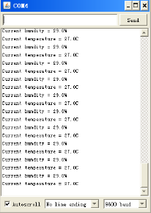
We hold it in hand and wait for a while... What is the change in the screen?
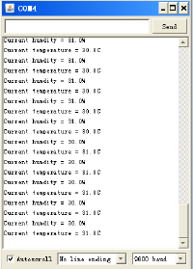
Look, the temperature is rising, the next time we can use it to test the temperature of the palm of the hand, ha ha... Then we have to give it a few breath try it
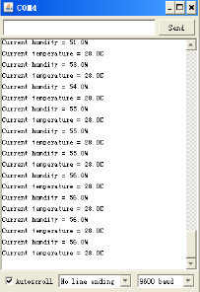
And imagine the same humidity became big, ha, this stuff is really good ah.... interested you can DIY (do it yourself) put in place do you often stay, that your heart has a bottom.
Concluding remarks

Module is introduced here to tell a, if you are interested in it can buy their own at home, slowly study, for using it to make a very creative things out, for the rest of your life add to the fun... ^ - ^

